

[Document title]

[Document subtitle]



[Date]

[Company name]

[Company address]

Contents

List of Figure 2

Code 3

F19_PP 3

Structure Analysis 7

Output Graph 9

Tower 9

CRANE/WINCH 10

BRIDGE/SPAN 10

Menu Output 11

Tower Structure 11

Crane/ Winch Structure 13

Bridge/Span Structure 15

# List of Figure

Figure 1: Tower Graph 9

Figure 2: Crane/ Winch Graph 10

Figure 3: Bridge/Span Graph 10

Figure 4; Tower selection 11

Figure 5: Tower Force and Cost 12

Figure 6: Tower Reaction 12

Figure 7: Crane Selection 13

Figure 8: Crane Reaction, Force and Cost 14

Figure 9: Bridge Structure 15

Figure 10: Cost and Clearance of bridge 15

Figure 11: Force and Reaction of bridge 16

# Code

## F19_PP

clc

clear all

close all

load materials.dat

load pricing.dat

while (1)

disp('******MENU*****')

fprintf('CHOOSE STRUCTURE:\n 1) TOWER\n 2) CRANE/WINCH\n 3) BRIDGE/SPAN\n ')

choose_str=input('ENTER A CHOICE:');

if (choose_str<0 || choose_str>3)

disp('You enter the Wrong Number ')

else

break

end

end

while(1)

disp('******MENU*****')

fprintf('CHOOSE MATERIAL:\n 1) ALUMINUM\n 2) STEEL\n 3) TITANIUM\n')

choose_mat=input('ENTER A CHOICE:');

if(choose_mat<0 || choose_mat>3)

disp('You enter the Wrong Number ')

else

break

end

end

a=1*10^-4;

s_f=2;

if(choose_mat==1)

W_max=(a*materials(7))/s_f;

W_fail=(a*materials(10))/s_f;

deformation=((W_max)/(materials(4)*a))*100;

mat_cost=pricing(4);

elseif (choose_mat==2)

W_max=(a*materials(8))/s_f;

W_fail=(a*materials(11))/s_f;

deformation=((W_max)/(materials(5)*a))*100;

mat_cost=pricing(5);

elseif (choose_mat==3)

W_max=(a*materials(9))/s_f;

W_fail=(a*materials(12))/s_f;

deformation=((W_max)/(materials(6)*a))*100;

mat_cost=pricing(6);

end

if (choose_str==1)

while (1)

disp('******MENU*****')

fprintf('CHOOSE A SIZE:\n 1) small (3.3 feet)\n 2) medium (6.6 feet)\n 3) large (16.4 feet)\n')

choose_size=input('ENTER A CHOICE:');

if(choose_size<0 || choose_size>3)

disp('You enter the Wrong Number ')

else

break

end

end

if(choose_size==1)

Footprint=3*3.3/3.28;

h= sqrt(3)*3.3/2;

fee=50;

% convert into feet for final display value

elseif(choose_size==2)

Footprint=3*6.6/3.28;

h= sqrt(3)*6.6/2;

fee=100;

else

Footprint=3*16.4/3.28;

h= sqrt(3)*16.4/2;

fee=250;

end

Clearance=4*h/3.28;

elseif (choose_str==2)

while(1)

disp(['WORKING LOAD (0 < MASS <', num2str(W_max*224720),' )'])

W=input('Enter the Working Load in lb :');

if (W<0 || W>(W_max*224720))

disp('You Enter the Wrong Working Load ')

else

break

end

end

% W=W*0.071429;

if (W>5000)

W=5000;

end

h= sqrt(3)*W/(2);

% first convert into newton then meter

Footprint=((((3*W)/4.5)/1000));

Clearance=((((4*h)/4.5)/1000));

fee=50;

elseif(choose_str==3)

while (1)

d=input(['HOW WIDE DO YOU NEED YOUR BRIDGE/SPAN? (< 164,' ,'FEET): ']);

if ((d*1.1)>6.56 && (d*1.1)<164)

break

else

disp('INVALID ENTRY...')

disp ('DISTANCE TOO LONG OR TOO SHOR')

end

end

d=d/3.28;

Clearance=((sqrt(3)*d)/2)/d;

Footprint=(2*d)/sqrt(3);

fee=52;

increment_fee=0;

for i=1:round(d)

increment_=0.02*fee;

increment_fee= increment_fee+ increment_;

end

fee=fee+increment_fee

end

disp('**********************************')

if(choose_str==1 && choose_mat==1)

disp('YOU HAVE CHOSEN: ALUMINUM TOWER ')

elseif(choose_str==1 && choose_mat==2)

disp('YOU HAVE CHOSEN: STEEL TOWER ')

elseif(choose_str==1 && choose_mat==3)

disp('YOU HAVE CHOSEN: TITANIUM TOWER ')

elseif(choose_str==2 && choose_mat==1)

disp('YOU HAVE CHOSEN: ALUMINUM CRANE/WINCH ')

elseif(choose_str==2 && choose_mat==2)

disp('YOU HAVE CHOSEN: STEEL CRANE/WINCH ')

elseif(choose_str==2 && choose_mat==3)

disp('YOU HAVE CHOSEN: TITANIUM CRANE/WINCH ')

elseif(choose_str==3 && choose_mat==1)

disp('YOU HAVE CHOSEN: ALUMINUM BRIDGE/SPAN')

elseif(choose_str==3 && choose_mat==2)

disp('YOU HAVE CHOSEN: STEEL BRIDGE/SPAN ')

elseif(choose_str==3 && choose_mat==3)

disp('YOU HAVE CHOSEN: TITANIUM BRIDGE/SPAN ')

end

if(choose_str~=2)

W=W_max*224720;

end

disp(['CLEARANCE: ',num2str(Clearance*3.28),' ft'])

disp(['FOOTPRINT: ',num2str(Footprint*3.28),' ft'])

disp(['MAX LOAD: ',num2str(W),' lb'])

fprintf('\n')

disp(['MAX REC LOAD :',num2str(round(W_max*224720)),' lb'])

disp(['MAX DEFORMATION: ',num2str(deformation/1000),' %'])

disp(['FAILURE LOAD: ',num2str(round(W_fail*224720)),' lb'])

if (choose_str==1)

load geomtopo1.mat

elseif (choose_str==2)

load geomtopo2.mat

elseif (choose_str==3)

load geomtopo3.mat

end

M=size(memnod);

c=M(2);

M=M(1);

N=size(nodmem);

N=N(1);

L=0;

for i=1:M

if (choose_str==1)

L=M;

L=L*c;

L=L+Clearance;

elseif (choose_str==2)

L=Footprint*3.3;

elseif (choose_str==3)

L=74.5 +fix(d);

end

end

for j=1:N

plot(x(j),y(j),'o','MarkerSize', 12,'color','k')

text(x(j)+.09,y(j)+0.09,num2str(j),'Color', [1,0,0] )

hold on

for i=1:M

if (memnod(M+i)==j)

% disp(['Counter ',num2str(i),'=',num2str(j),' node is connetec with ',num2str(memnod(i))])

plot([x(memnod(i)) x(j)],[y(memnod(i)) y(j)],'color','k','LineWidth',2)

text(mean([x(memnod(i)) x(j)])+.09,mean([y(memnod(i)) y(j)])+.09,num2str(i),'Color', [0,0,1] )

hold on

end

end

end

axis equal

axis off

disp('**********************************')

disp('COST: ')

disp(['MATERIALS : $',num2str(mat_cost*L)])

disp(['FEES : $ ',num2str(fee)])

disp(['TAX : $ ',num2str(mat_cost*L*.08)])

disp('----------------')

disp(['TOTAL : $ ',num2str(mat_cost*L+fee+(mat_cost*L*.08))])

Youngs_modulus=1.12*10^11 +zeros(M,1);

[Force,deformtion,Reaction]=Structure_Analysis(choose_str,N,W_max,Youngs_modulus);

Force=Force*10^6;

deformtion=deformtion*10^6;

Reaction=Reaction*10^6;

disp ('MEMBER FORCE DEFORMATION')

for i=1:2*N-3

disp ([num2str(i),' ',num2str(Force(i)), ' ', num2str(deformtion(i))])

end

i=1;

disp('REACTION(N)')

for i=1:length(Reaction)

disp(num2str(Reaction(i)))

end

if (choose_str==1)

save Analysis1

elseif (choose_str==2)

save Analysis2

elseif (choose_str==3)

save Analysis3

end

## Structure Analysis

function [Force,Deformation,Reaction]=Structure_Analysis(Structure,N,W,Youngs_modulus)

a=10^-4;

if (Structure==1)

alph=atan((sqrt(3)*3)/2);

beta=atan(sqrt(3)/2);

angle=pi/3;

W=0.0125;

B=[zeros(2*N-1,1);W];

A1=[cos(alph) cos(beta) 0 0 0 0 0 0 0 0 0 0 0 1 0 0];

A2=[sin(alph) sin(beta) 0 0 0 0 0 0 0 0 0 0 0 0 1 0];

A3=[0 0 -cos(beta) -cos(alph) 0 0 0 0 0 0 0 0 0 0 0 0];

A4=[0 0 sin(beta) sin(alph) 0 0 0 0 0 0 0 0 0 0 0 1];

A5=[-cos(alph) 0 0 0 1 0 cos(angle) 0 0 0 0 0 0 0 0 0];

A6=[-sin(alph) 0 0 0 0 0 sin(angle) 0 0 0 0 0 0 0 0 0];

A7=[0 -cos(beta) cos(beta) 0 -1 1 0 -cos(angle) cos(angle) 0 0 0 0 0 0 0];

A8=[0 -sin(beta) -sin(beta) 0 0 0 0 sin(angle) sin(angle) 0 0 0 0 0 0 0];

A9=[0 0 0 cos(alph) 0 -1 0 0 0 -cos(angle) 0 0 0 0 0 0];

A10=[0 0 0 -sin(alph) 0 0 0 0 0 sin(angle) 0 0 0 0 0 0];

A11=[0 0 0 0 0 0 -cos(angle) cos(angle) 0 0 1 cos(alph) 0 0 0 0];

A12=[0 0 0 0 0 0 -sin(angle) sin(angle) 0 0 0 sin(alph) 0 0 0 0];

A13=[zeros(1,8) -cos(angle) cos(angle) -1 0 -cos(alph) zeros(1,3)];

A14=[zeros(1,8) -sin(angle) -sin(angle) 0 0 sin(alph) zeros(1,3)];

A15=[zeros(1,11) -cos(alph) cos(alph) zeros(1,3)];

A16=[zeros(1,11) -sin(alph) -sin(alph) zeros(1,3)];

A=[A1;A2;A3;A4;A5;A6;A7;A8;A9;A10;A11;A12;A13;A14;A15;A16];

X=inv(A)*B;

elseif(Structure==2)

% N=6;

gamma=atan(sqrt(3)/2);

angle=pi/3;

W=0.0125;

B=[zeros(2*N-1,1);W];

A1=[1 cos(angle) zeros(1,7) 1 0 0];

A2=[0 sin(angle) zeros(1,8) 1 0];

A3=[-1 0 -cos(angle) cos(angle) zeros(1,8)];

A4=[0 0 sin(angle) sin(angle) zeros(1,7) 1];

A5=[0 -cos(angle) cos(angle) 0 1 cos(angle) zeros(1,6)];

A6=[0 -sin(angle) -sin(angle) 0 0 sin(angle) zeros(1,6)];

A7=[zeros(1,3) -cos(angle) -1 0 -cos(angle) 0 cos(angle) zeros(1,3)];

A8=[zeros(1,3) -sin(angle) 0 0 sin(angle) 0 sin(angle) zeros(1,3)];

A9=[zeros(1,5) -cos(angle) cos(angle) cos(gamma) zeros(1,4)];

A10=[zeros(1,5) -sin(angle) -sin(angle) sin(gamma) zeros(1,4)];

A11=[zeros(1,7) -cos(gamma) -cos(angle) zeros(1,3)];

A12=[zeros(1,7) -sin(gamma) -sin(angle) zeros(1,3)];

A=[A1;A2;A3;A4;A5;A6;A7;A8;A9;A10;A11;A12];

X=inv(A)*B;

elseif (Structure==3)

angle =pi/3;

A1=[cos(angle) 1 zeros(1,13) 1 0 0 ];

A2=[sin(angle) zeros(1,15) 1 0];

A3=[-cos(angle) 0 cos(angle) 1 zeros(1,14)];

A4=[-sin(angle) 0 -sin(angle) zeros(1,15)];

% A5=[0 -1 -cos(angle) 0 cos(angle) 1 zeros(1,12)] ;

A5=[];

for i=1:N*2

A5=[A5 2 * rand - 1];

end

A6=[0 0 sin(angle) 0 sin(angle) zeros(1,13)];

A7=[zeros(1,3) -1 -cos(angle) 0 cos(angle) 1 zeros(1,10)];

A8=[zeros(1,4) sin(angle) 0 sin(angle) zeros(1,11)];

A9=[zeros(1,5) -1 -cos(angle) 0 cos(angle) 1 zeros(1,8)];

% A10=[zeros(1,6) sin(angle) 0 sin(angle) zeros(1,9)];

A10=[];

for i=1:N*2

A10=[A10 2 * rand - 1];

end

A11=[zeros(1,7) -1 -cos(angle) 0 cos(angle) 1 zeros(1,6)];

A12=[zeros(1,8) sin(angle) 0 sin(angle) zeros(1,7)];

A13=[zeros(1,9) -1 -cos(angle) 0 cos(angle) 1 zeros(1,4)];

A14=[zeros(1,10) sin(angle) 0 sin(angle) zeros(1,5)];

A15=[zeros(1,9) -1 cos(angle) 0 cos(angle) zeros(1,5)];

A16=[zeros(1,10) -sin(angle) 0 -sin(angle) zeros(1,5)];

A17=[zeros(1,13) -1 cos(angle) zeros(1,3)];

A18=[zeros(1,14) sin(angle) 0 0 1];

A=[A1;A2;A3;A4;A5;A6;A7;A8;A9;A10;A11;A12;A13;A14;A15;A16;A17;A18];

B=[zeros(N,1);W;zeros(N-1,1)];

X=(A'*B)./0.2126;

end

for i=1:2*N-3

Force(i)=X(i);

Deformation(i)=(X(i)/(a*Youngs_modulus(i)))*100;

end

i=1;

for j=length(Youngs_modulus)+1:length(X)

Reaction(i)=X(j);

i=i+1;

end

end

# Output Graph

## Tower

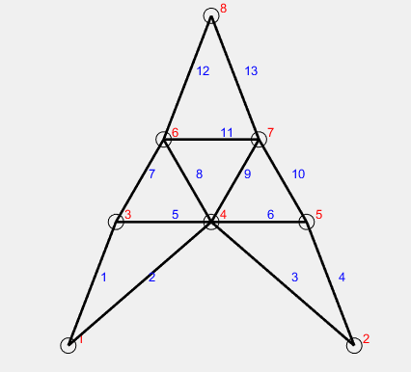

Figure : Tower Graph

## CRANE/WINCH

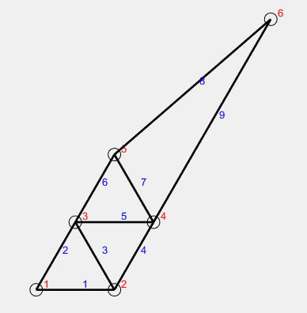

Figure : Crane/ Winch Graph

## BRIDGE/SPAN

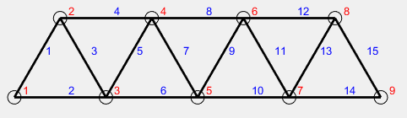

Figure : Bridge/Span Graph

# Menu Output

## Tower Structure

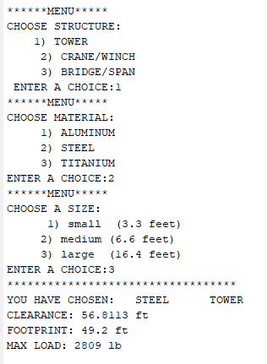

Figure ; Tower selection

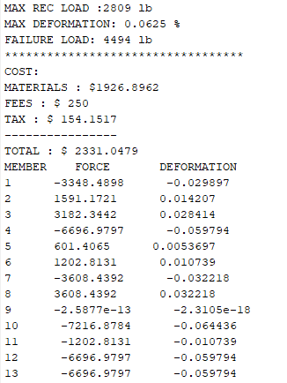

Figure : Tower Force and Cost

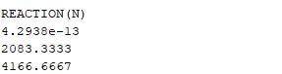

Figure : Tower Reaction

## Crane/ Winch Structure

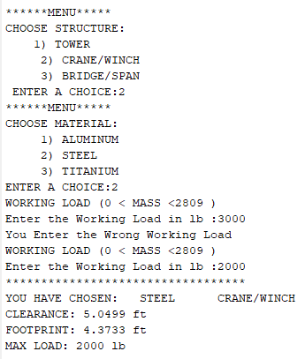

Figure : Crane Selection

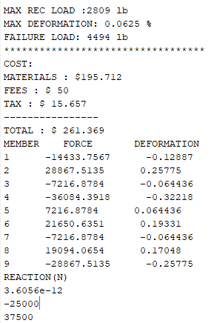

Figure : Crane Reaction, Force and Cost

## Bridge/Span Structure

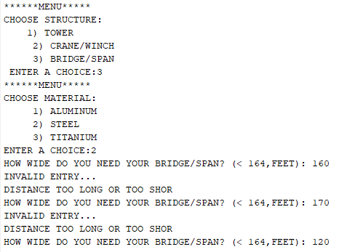

Figure : Bridge Structure

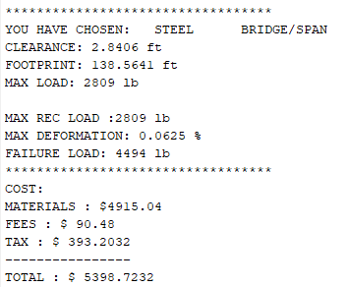

Figure : Cost and Clearance of bridge

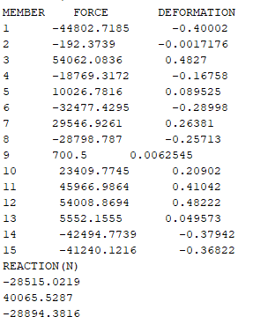

Figure : Force and Reaction of bridge